Project Draft Proposal

Title of The Project : **Acoustic Detection and Classification of under water speech signals**

Author: Suhail K

Reg. No.: TVE17ECSP16

Degree: M. Tech in Signal Processing

Guide: Mr. Ebin M Manuel

Asst professor ,Department of ECE

College of Engineering Trivandrum

Date of Submission: 25/09/2018

**Introduction**

Underwater acoustics is the study of the propagation of [sound](https://en.wikipedia.org/wiki/Sound) in [water](https://en.wikipedia.org/wiki/Water) and the interaction of the [mechanical waves](https://en.wikipedia.org/wiki/Mechanical_wave) that constitute sound with the water, its contents and its boundaries. The water may be in the ocean, a lake, a river or a [tank](https://en.wikipedia.org/wiki/Water_tank). Typical frequencies associated with underwater acoustics are between 10 [Hz](https://en.wikipedia.org/wiki/Hertz) and 1 [MHz](https://en.wikipedia.org/wiki/MHz" \o "MHz). The propagation of sound in the ocean at frequencies lower than 10 Hz is usually not possible without penetrating deep into the seabed, whereas frequencies above 1 MHz are rarely used because they are absorbed very quickly. Underwater acoustics is sometimes known as [hydroacoustics](https://en.wikipedia.org/wiki/Hydroacoustics" \o "Hydroacoustics).

The problem of acoustic detection and classification can be solved by signal processing and machine learning tools

**Motivation**

Recent advancements in maritime technologies, pure oceanic research and military techniques related to underwater acoustics have introduced us to a new class of problems in digital signal processing. Apart from acoustic measurements, underwater classification to identify signatures

poses a challenging task at hand due to typical profile of anthropogenic noise which is very complex. Moreover, unavailability of large relevant datasets makes it hard to achieve high accuracy in classification.

Under water acoustics have wide applications in the field such as under water communication, underwater navigation and tracking, seismic exploration, weather and climate observation , marine biology, particle physics etc.

**Methodology**

The acoustic detection and classification problem can be done by three steps

1.**Pre-processing of Signals .**

The sounds which are in very small amount and recorded with single hydrophone at same depth, those types of sounds are divided into two equal parts (training and testing parts)

**2. Feature Extraction**

The classification model starts with the feature extraction part where signals are manipulated, and useful trends are extracted from them. Features comprise of t time domain, frequency domain ,perceptual features etc

**3.Classification**

Classification can be done by many techniques such as by using multiclassifiers, artificial neural network, probabilistic neural network etc.

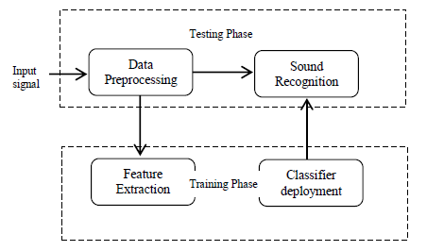

Fig 1: Block diagram of underwater acoustic recognition system

**Project Plan**

**Third Semester**

* Simulate all the signal processing operations related to the thesis work.
* Study about various techniques for under water channel estimation.
* Collect databases required for the work.
* To make thorough knowledge of various features that is used for the under water acoustic detection and classification.
* Simulate all the studied features and channel estimation techniques.

**Fourth semester**

* Complete the machine learning parts of the work.
* Find the best approach and implement the system using the neural network techniques.
* Analyse the performance of the system.